**Basics Of Git**

**Introduction** :-

Git is a version control system which enables you to track changes to files. It is entirely file based itself, meaning there is no additional software or applications required except Git istelf.

Using Git, you are able to revert files back to previous versions, restore deleted files, remove added files and even track down where a particular line of code was introduced.

Git creates a .git folder (in the current folder) to store the details of the file system - this folder contains all the data required to track your files and is known as a **repository**, or repo.

**Basic Git Commands :-**

* **Open Terminal in Folder Of Your Project**
* **git init :-** initialise (create) a repository.
* **git clone :-** copy an existing repository.
* **git add <filename>** :- Add a particular file in staging stage before commit we have to add file to staging stage.
* **git add * :-** Add full folder to staging Stage.
* **git status** :- List the files you've changed and those you still need to add or commit.
* **git commit -m "Commit message**" :- Commit changes to head (but not yet to the remote repository)
* **git push origin master** - Send changes to the master branch of your remote repository
* **git log** :- Shows record of All the commits made till now.
* git checkout -b :- Create a new branch and switch to it
* git checkout <branchname> :- Switch from one branch to another
* git merge <branchname> :- To merge a different branch into your active branch.
* Git diff :- Show all changes to file made so far.
* **git reset <commit no> :- It rollback to the particular commit.**
* **git revert HEAD :-** The net effect of the **git revert** command is similar to reset, but its approach is different. Where the **reset** command moves the branch pointer back in the chain (typically) to "undo" changes, the **revert** command adds a new commit at the end of the chain to "cancel" changes.

**Some Screen shots of Git Commands**

1)

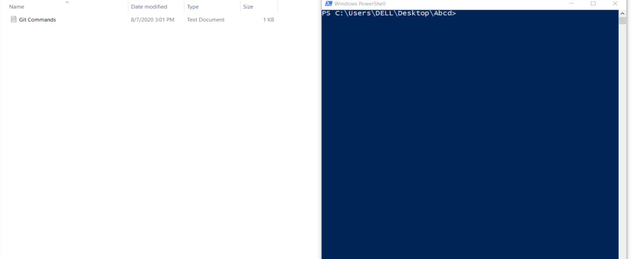

Open Terminal in Your Folder.

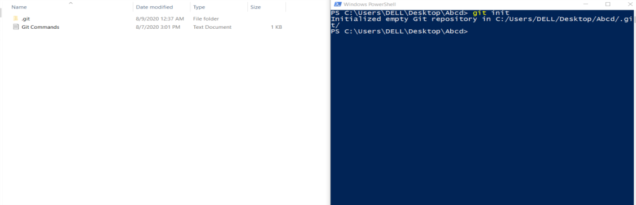

.git folder is made after running init command that will keep all the records of your project.

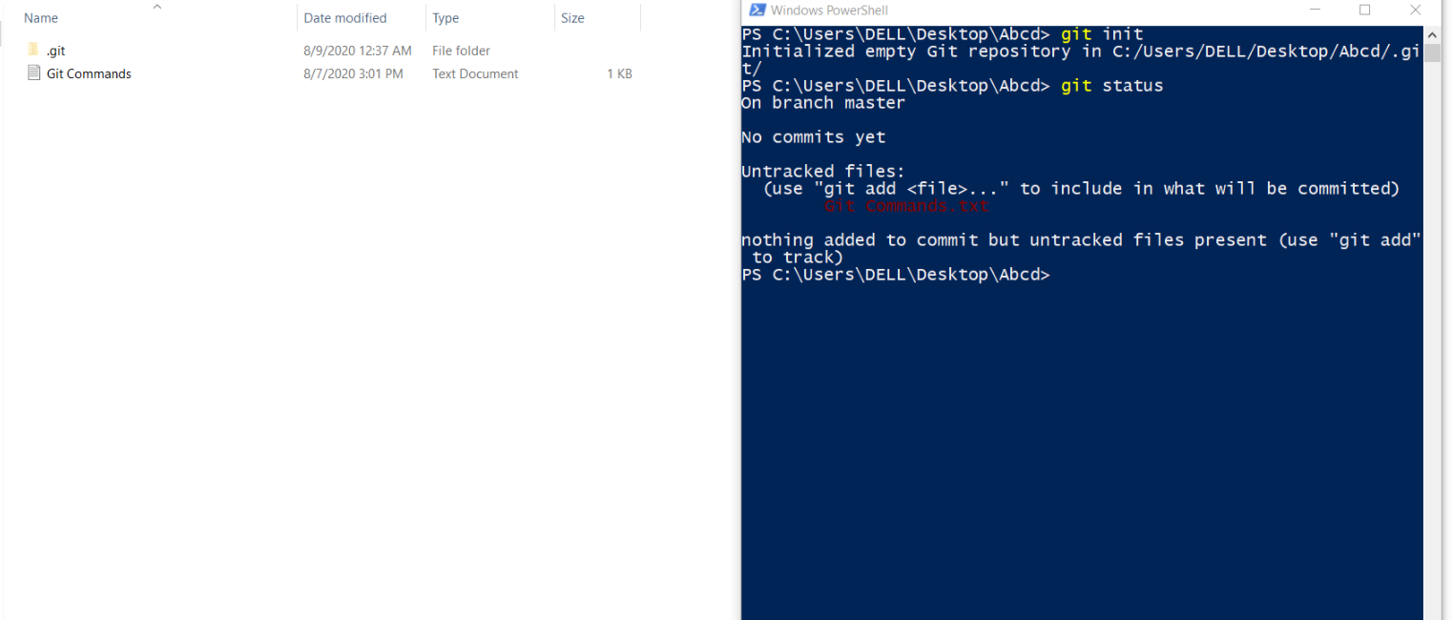

After running git Status command The file which is not added to staging stage ie (not used add command) shows those file in red color.

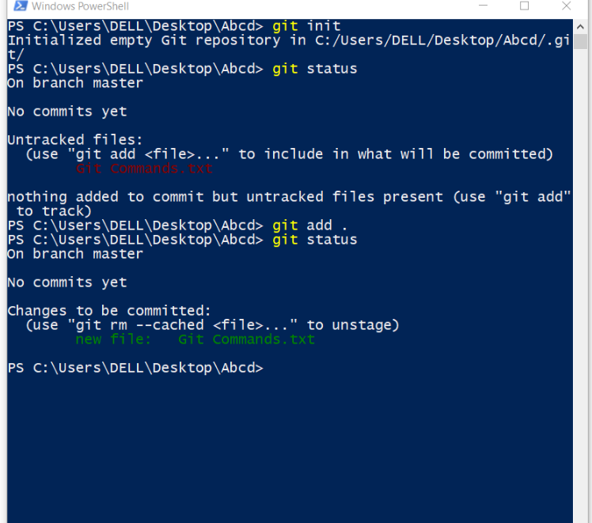

After Using add command then git status shows that file in green color Now you are ready to commit those files.

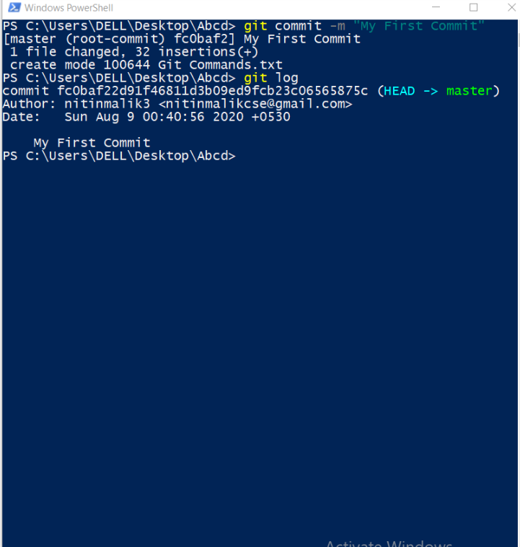

Finally Used Commit to comit those changes which we have made so far and after that git log shows all the commits made so far.